- H₀: Customers choose all snack types equally.
H₁: Customers do not choose all snack types equally.

ii.
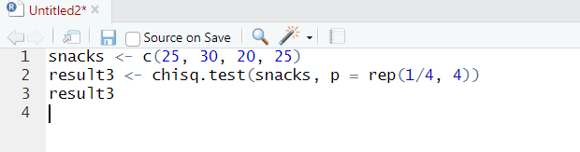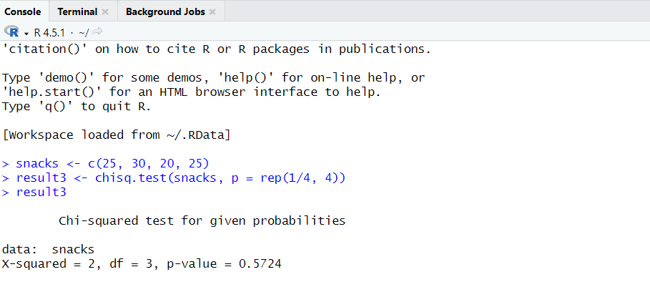

- Since p-value = 0.5724 > 0.05, Fail to reject H₀. There is no significant difference among snack type choices customers choose snacks equally likely.

